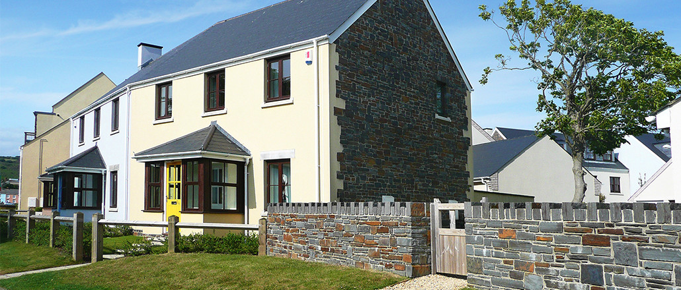

**Chandlers Yard Residential Development – 40 Residential Units**

**Design, manufacture and erection of 40 residential units in Burryport, Carmarthenshire. Constructed in 2008, Seven Oaks provided the timber frames, loose joists and roof structures for 18 apartments, 19 houses and 3 coach houses on this residential development.**

**Type of Project - Residential**

**Client – Dawnus Construction**